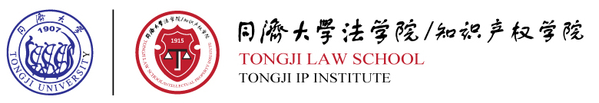
Invitation to the 2014 Tongji German-Sino Law Forum
“Recent developments of Economic Law”

Shanghai, February 24th 2014

We are pleased to invite you to participate in the 2014 Tongji German-Sino Law Forum at April 3rd 2014. This one day event will be hosted by the Law School of Tongji University, in particularthe Sino-German Institute for International Economic Law (SGIEL).
The SGIEL has beenestablished in 2013 by the partners based on the standingco-operation between Tongji University Shanghai, Humboldt-University Berlin and Konstanz University with regardto the Dual Master Program for law students. The purpose of the Institute consists not only in the promotion of legal education, especially in the area of international economic law including Intellectual Property law, International law etc. Simultaneously, the communication of lecturers, students and research fellowswill is improved. By organizing international conferences concerningcurrent issues of Chinese-German economic law the Institute will provide a forumfor the exchange of experience and consultation for German companies operating in China and Chinese firms, whichwant to do business in Germany. Currently the Institute has 20 researchers: 11 of them are German professors and every Chinese member obtained a PhD degree in Germany.
The first Tongji Law Forum took place in 2013 in Shanghai and proved to be a valuable international platform for researchers; consultants and other legal professionals to exchange ideas and discuss questions of common concern.The upcoming meeting will focus on “Recent development of Economic Law”.
Please find attached the schedule of the meeting. We look forward to meeting you at Tongji.

Best regards.

Prof. Dr. jur. Xujun GAO
Humboldt Scholar
Director of SGIEL
Tongji University
Email: Gaoxujun@mail.tongji.edu.cn
Phone: 86-21-65981087
Room 1303, 1239, Siping Road, Shanghai, China, 200092

